
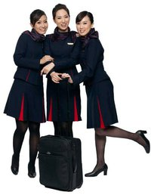
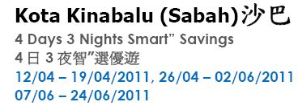
0
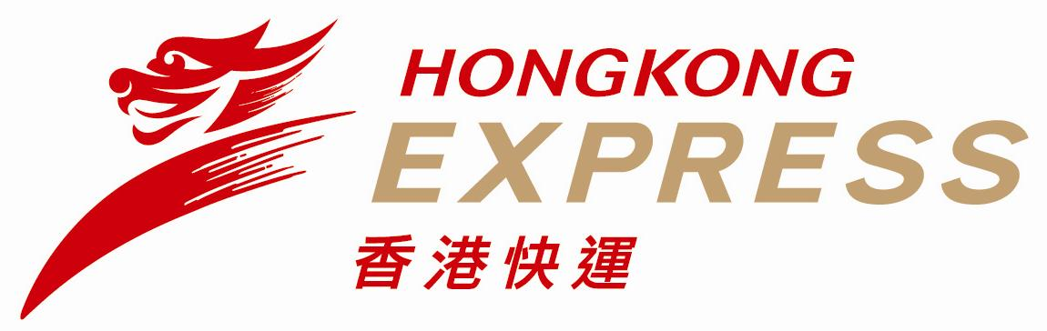

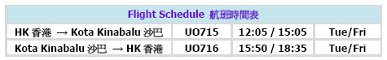

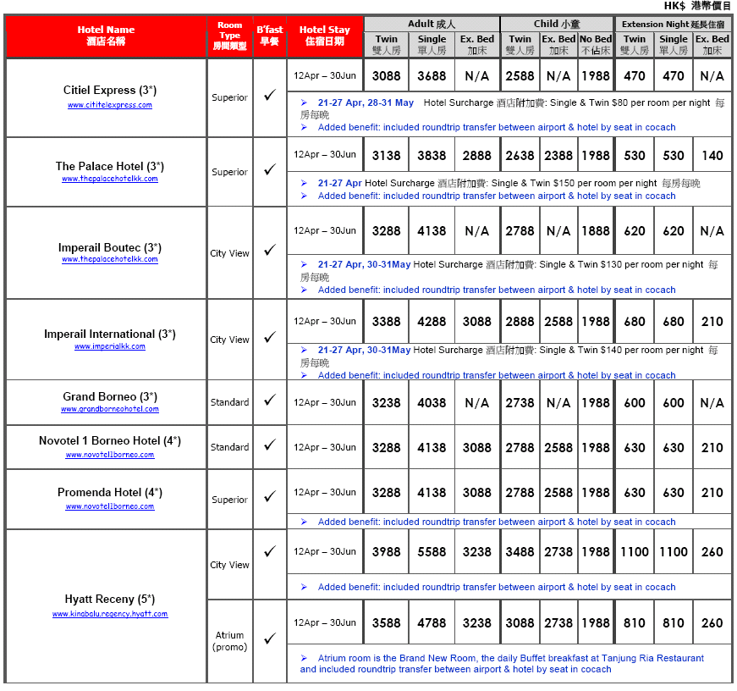

MY-WAY (TST)Operated by Bao Shinn Int’l Express Ltd.
(Licence No. 352614)
Patterson Holidays (HK)Operated by H.C.Patterson & Co Ltd.
(Licence No. 350200) : 3188 6611 : 3188 6622 : 3102 2371 : 2868 4213Website : www.baoshinn.com.hk Website: www.pattersontravel.com.hkE mail : reservation@baoshinn.com.hkE mail: package@pattersontravel.com.hkAddress: Flat A-B, 8/F, No. 8 Hart Avenue, Tsim Sha Tsui, KLN
**百樂門囍宴樓上** ( MTR Exit A2, D2 or N1 )Address: FlatF, 8/F, No. 8 Hart Avenue, Tsim Sha Tsui, KLN
**百樂門囍宴樓上** ( MTR Exit A2, D2 or N1 )Last Update : 14Apr11 HKAHBKI3D2N01 (AC200+100/EN50)Please call for duplicated e-mail or needless, thank you!

